# **Confusion Matrix & ROC Curve**

Krishna Kumar Veeraputhiran

Grand Canyon University

DSC 540 – O500 – Machine Learning for Data Science

Dr. Aiman Darwiche

August 18,2021

# **Confusion Matrix & ROC Curve**

Confusion Matrix and ROC curve are two ways to summarize and visualize the performance outcome of a supervised classification model. In this report we will discuss in depth on how both confusion matrix and ROC plots are used.

**Confusion Matrix:**

As mentioned earlier, a confusion matrix is a technique to summarize the performance of a classification model in a tabular format representing the actual value and the corresponding predicted value. Usually a model’s accuracy can be calculated by finding the ratio of the correct predictions to the total predictions. For e.g. let us say if the dataset with more than two classifications on which a classification model is executed yields an accuracy percentage of 90%, then just by looking at the overall model’s accuracy will not let us know which classification was predicted the most correctly or which has the higher error rate. This is where the Confusion matrix plays a major role. A confusion matrix is a simple representation of correct and incorrect predictions with count values broken down by each class.

Below is a visualization of the confusion matrix that has been derived in predicting the MNIST digits. We can see the labels in both y and the x-axis. The label values in the y-axis (True Label) represents the actual number the image represents and the label value in the x-axis (Predicted Label) is what the classification model predicted based on the test images. From the below Confusion matrix we can say that there are 9 classifications in the dataset and the diagonal element in the matrix represents the total number of labels that are correctly predicted.

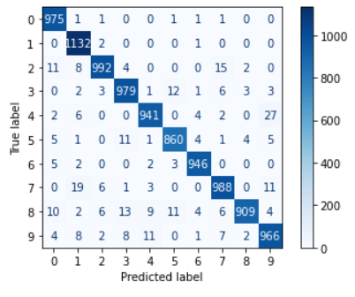

For e.g. let us take the example of the label 1, from the confusion matrix, we can say that there are 980 images with label as 1 and out of which 975 are correctly predicted as 1. Whereas the remaining five images are incorrectly predicted. The biggest advantage of the confusion matrix is that we can see the accuracy of the classes individually and it provides insights on the type of error the classification algorithm makes. We can also take necessary steps to account for unequal error costs. In machine learning any supervised classification model that we create need to evaluated and confusion matrix is one of the key evaluation tool to evaluate the model and can provide a benchmark for improving a specific class accuracy or the overall model accuracy.

**ROC Curve:**

The Receiver Operator Curve (ROC Curve) is an evaluation metric for binary Classification model. In detail, a ROC curve plots the True Positive Rate (Sensitivity) vs the False Positive Rate (1-Specificity) at various threshold values and thus separating the signal from noise. The TPR and FPR can be given as,

TPR or Sensitivity = True Positive / (True Positive +False Negative)

FPR = False Positive / (True Negative +False Positive)

The Area under the Curve (AUC) is the ability of a classifier to distinguish between the classes and is used as the summary for ROC curve. Higher the value of AUC, better the model in classifying all the positive and negative classes. Below is a sample ROC curve that has been calculated for the K-Nearest Neighbor classifier model in predicting the digits of the MNIST digit images. In the below curve a higher X-axis value indicates higher number of False Positives than true negatives while a higher value of Y-axis means higher number of True Positives than False negatives.

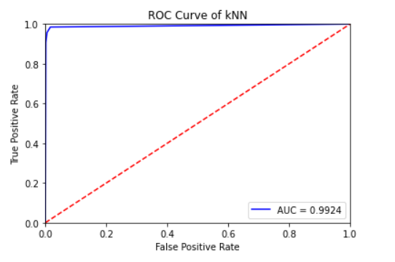

The ROC plot helps us to visualize the performance of the classifier model at different thresholds. A model with AUC value closer to 1 means it has a good measure of distinguishing between all the positive and negative class correctly. When AUC is 0.5 (Red line in the above plot) then we can confirm that the model is randomly predicting the outcome of data points. We can see from above, the AUC is almost equal to 1 meaning the model used to classify the images is able to classify the positive and negative class correctly in majority of the cases

The ROC curve can also be applied for multi-class classification cases too. Consider the example above of predicting the values of MNIST images. This is a multi-class classification (total of 10 classes). Here the ROC for each class will be generated as classifying the same class against the other class. For example in the above case the ROC for class 0 will be class 0 against rest of the classes.

# **References**

Larose, C. D., & Larose, D. T. (2019). *Data science using Python and R*. John Wiley & Sons, Inc.

Bhandari, A. (2020, June 20). *AUC-ROC curve in machine learning clearly explained*. Analytics Vidhya. https://www.analyticsvidhya.com/blog/2020/06/auc-roc-curve-machine-learning/.

Brownlee, J. (2016, November 18). *What is a confusion matrix in machine learning*. Machine Learning Mastery. https://machinelearningmastery.com/confusion-matrix-machine-learning/.